

#### Itgalpura, Rajanukunte, Bengaluru - 560064

School of Engineering

A Project Report on

**“CUSTOMER CHURN PREDICTION**

**USING MACHINE LEARNING TECHNIQUES”**

#### Submitted in partial fulfillment of the requirement for the course

Applied Machine Learning (CSE-3087)

Submitted by:

|  |  |
| --- | --- |
| Student Name | Roll Number |
| JAYANTH MAYUR H | 20221CSG0120 |
| SURAJ LAXMAN SHANBHAG | 20221CSG0084 |

DECEMBER 2024

## ABSTRACT

Customer churn, the phenomenon where customers stop doing business with a company, represents a critical challenge across various industries, including telecommunications, banking, e-commerce, and subscription-based services. High churn rates can lead to significant financial losses and hinder a company's growth, making it essential for businesses to predict and mitigate churn. This report explores the application of machine learning (ML) techniques to predict customer churn, providing valuable insights that can help organizations implement targeted retention strategies. By utilizing predictive modeling, businesses can identify at-risk customers early and engage them with personalized offers, incentives, or interventions before they leave.

In this study, we evaluate several machine learning models, including Logistic Regression, Random Forest, and Gradient Boosting, on a customer churn dataset sourced from a telecommunications company. The models are trained to classify customers into two categories: those who will churn and those who will remain loyal. The dataset comprises various features such as demographic information, usage patterns, customer service interactions, and billing data. Each of these models was assessed on multiple evaluation metrics, including accuracy, precision, recall, F1-score, and the area under the ROC curve (ROC-AUC), to determine their ability to accurately predict churn.

The study highlights the importance of data preprocessing and feature selection, emphasizing how careful handling of missing data, scaling of numerical variables, and encoding of categorical variables can significantly improve model performance. Additionally, we discuss the role of hyperparameter tuning in optimizing the performance of each model. Techniques such as GridSearchCV and RandomizedSearchCV were applied to fine-tune the models, ensuring the best possible predictions.

Among the models evaluated, Gradient Boosting (specifically XGBoost) achieved the highest predictive accuracy and robustness, outperforming both Logistic Regression and Random Forest. This model demonstrated superior recall, indicating its ability to correctly identify a higher proportion of customers who were likely to churn. The findings suggest that machine learning-based churn prediction is a highly effective tool for businesses seeking to minimize churn and improve customer retention.

In conclusion, this report demonstrates the power of machine learning algorithms in predicting customer churn, offering practical insights for businesses to retain valuable customers. The results underline the importance of using advanced techniques such as Gradient Boosting for churn prediction, while also stressing the need for ongoing model refinement and real-time prediction capabilities. Future work can explore incorporating additional features, such as customer sentiment analysis and transaction history, to further improve prediction accuracy and create a more comprehensive churn prediction system.

## INDEX TERMS

Customer Churn Prediction, Machine Learning, Data Preprocessing, Logistic Regression, Random Forest, Gradient Boosting

## INTRODUCTION

Customer churn is one of the most significant challenges faced by businesses across various industries, where a business loses customers over time. This problem is especially relevant in highly competitive markets, where retaining customers is more cost-effective than acquiring new ones. Accurate prediction of churn enables businesses to implement retention strategies proactively.

In this project, we apply machine learning (ML) algorithms to predict customer churn based on historical data. The project focuses on various supervised learning algorithms, comparing their performance to determine the best-fit model for predicting customer churn. We discuss the various preprocessing techniques used, model evaluation methods, and provide insights into how businesses can utilize churn predictions to improve customer retention.

## RELATED WORK

Customer churn prediction has been a subject of many studies over the past decade. Early methods relied heavily on rule-based systems and statistical models. However, with the advent of machine learning, various algorithms have been employed to enhance prediction accuracy.

* **Logistic Regression**: Often used in binary classification tasks like churn prediction. Studies have shown its effectiveness in identifying customers at risk of leaving, especially when combined with feature engineering techniques.
* **Random Forest**: This ensemble method has been widely used for churn prediction due to its robustness against overfitting and ability to handle large datasets with high-dimensional features.
* **Gradient Boosting**: Algorithms like XGBoost and LightGBM have demonstrated superior performance in churn prediction tasks, offering higher accuracy by leveraging boosting techniques.

Research has also highlighted the importance of data preprocessing, feature engineering, and model selection. Methods like SMOTE (Synthetic Minority Over-sampling Technique) are commonly used to handle class imbalances, while cross-validation ensures the model's generalizability.

# LITERATURE SURVEY

In recent years, machine learning methods have revolutionized churn prediction. The application of various algorithms and techniques has led to significant improvements in predictive accuracy. A few key studies are outlined below:

1. **Study on Logistic Regression for Customer Churn**: This study applied logistic regression for predicting churn in telecom industries, emphasizing the importance of demographic features like age, tenure, and monthly charges as crucial predictors of churn.
2. **Random Forest and Feature Importance**: Research by R. B. Pichappan explored the use of random forests to predict churn, focusing on feature importance ranking. It highlighted that customer engagement metrics, such as usage frequency and call duration, were strong indicators of churn.
3. **Deep Learning for Churn Prediction**: Recent advancements also saw the incorporation of deep learning models for churn prediction. While neural networks require large datasets, they can model complex patterns and improve predictions significantly.

This literature indicates that there is no one-size-fits-all approach for churn prediction. Each dataset requires a tailored approach, and the choice of algorithm must be made based on specific characteristics of the data and the business requirements.

**IMPLEMENTATION**

The implementation of the churn prediction model follows a standard machine learning workflow:

1. **Data Collection** :  
   A dataset containing customer demographic information, usage patterns, and historical churn data was used. Features such as age, tenure, account type, and service usage were included in the dataset.
2. **Data Preprocessing** :  
   Data was cleaned to remove missing values, and categorical variables were encoded using one-hot encoding. Continuous variables were scaled using StandardScaler. The dataset was then split into training and testing subsets.
3. **Model Training** :  
   Three machine learning models were trained:

* **Logistic Regression**: A simple model for binary classification.
* **Random Forest**: An ensemble method that uses decision trees to predict churn.
* **Gradient Boosting (XGBoost)**: A boosting model known for its performance in classification tasks.

The models were trained on the training set using cross-validation to tune the hyperparameters.

#### **Exploratory Data Analysis (EDA) :**

Before training the models, an **Exploratory Data Analysis (EDA)** was conducted to understand the underlying patterns in the dataset. The EDA steps involved:

* **Data Visualization:** Various visualizations, such as histograms, bar charts, and scatter plots, were used to examine the distribution of features like age, tenure, and usage patterns. These visualizations helped identify patterns, outliers, and correlations between features and the target variable (churn).
* **Correlation Analysis:** A correlation matrix was created to explore the relationships between the numerical features and the target variable. This helped in understanding which features are most strongly related to customer churn.
* **Class Imbalance:** The distribution of the target variable (churned vs. non-churned) was checked. In many churn prediction datasets, the churn class is often imbalanced, which can lead to biased model predictions. Techniques like oversampling the minority class or adjusting class weights in the model were considered to address this issue.
* **Feature Selection:** Based on the insights gained during EDA, features that showed minimal correlation with churn or high multicollinearity were removed. This step ensured that the models focused on the most relevant features, improving their efficiency and accuracy.

1. **Model Evaluation** :

Performance metrics such as accuracy, precision, and ROC-AUC were used to evaluate the models. Cross-validation helped ensure that the models did not overfit the training data.

1. **Hyperparameter Tuning** :

Hyperparameters for each model were tuned using GridSearchCV and RandomizedSearchCV to optimize performance. The Random Forest and XGBoost models demonstrated superior performance after hyperparameter optimization.

**Implementation Details**

#### 1. **Dataset Description**

* The dataset utilized for this project contains customer credit card’s usage information, including features such as age, tenure, account type, service usage patterns, and whether a customer has churned or not.
* Data preprocessing was performed to remove unnecessary columns such as customer IDs and irrelevant features. Categorical variables, such as account type and service plan, were transformed into numerical values using one-hot encoding. Continuous variables like age and tenure were standardized using **StandardScaler**.

#### 2. **Handling Missing Data**

* Missing values in the data-set were checked using isnull().sum() to identify if there were any gaps in the data.
* After identifying that there were no missing values, the dataset was cleaned to ensure that all rows were valid and ready for analysis. For any columns with sparse data, imputation methods were applied to ensure consistency.

#### 3. **Feature Engineering**

* The target variable (churn) was created, where the dataset indicates whether a customer has churned (1) or stayed (0). This was based on historical churn data.
* Redundant columns such as customer ID or service start dates were dropped to reduce noise and improve model performance.
* **Feature scaling** was performed on numerical features using **StandardScaler**, ensuring all numerical inputs had a mean of 0 and standard deviation of 1 to avoid bias during model training.

#### 4. **Data Splitting**

* The dataset was split into training and testing sets using an 80-20 ratio through the train\_test\_split method. The training data (80%) was used to train the model, and the testing data (20%) was used to evaluate model performance on unseen data.

#### 5. **Model Selection and Training**

* Three machine learning models were selected for churn prediction:
  + **Logistic Regression:** A simple yet effective binary classifier.
  + **Random Forest Classifier:** An ensemble method to improve accuracy by averaging predictions from multiple decision trees.
  + **Gradient Boosting (XGBoost):** A powerful boosting algorithm designed for high performance.
* Hyperparameters were set and tuned for each model:
  + For Random Forest, the number of estimators was set to 100 (n\_estimators=100).
  + For XGBoost, hyperparameters such as learning rate and maximum depth were adjusted using GridSearchCV.
* Models were trained on the scaled training data using cross-validation to minimize overfitting and to get a more generalizable model.

#### 6. **Model Evaluation**

* The model performance was evaluated using the following metrics:
  + **Accuracy Score:** Overall correctness of the model.
  + **Confusion Matrix:** To visualize the true positives, true negatives, false positives, and false negatives.
  + **ROC Curve and AUC:** To assess the model's ability to distinguish between churned and non-churned customers.
  + **Classification Report:** To evaluate the model's precision, recall, and F1-score.
* The final model (XGBoost) showed superior performance in terms of accuracy and recall, which is crucial in churn prediction to minimize the risk of losing valuable customers.

#### 7. **Visualizations**

* **Feature Importance:** A bar chart was created to display the importance of each feature in predicting customer churn, showing which factors have the most influence on the churn decision.
* **Heatmap for Confusion Matrix:** A heatmap was generated to visualize the results from the confusion matrix, aiding in the understanding of the model's misclassifications.
* **ROC Curve:** The ROC curve was plotted to evaluate the tradeoff between sensitivity and specificity, and the Area Under the Curve (AUC) was calculated to measure the model's discriminatory power.
* **Pairplots:** Pairwise relationships between key features, such as tenure and account type, were explored using pairplots to visualize the data distribution.

#### 8. **Prediction Process**

* For making predictions, the input features were preprocessed and scaled in the same way as the training data.
* The trained model was then used to output the predicted probabilities and the final churn class (churned or not churned).

#### 9. **Model Deployment**

* The trained machine learning model can be deployed as a web application using frameworks like **Flask** or **FastAPI**. These frameworks can create an API that takes customer data as input and returns a churn prediction.
* For mobile applications, frameworks such as **TensorFlow Lite** or **Core ML** can be used to deploy the churn prediction model, enabling real-time churn prediction directly on mobile devices.

#### 10. **Real-time Predictions**

* After deployment, the model can process new customer data, extract necessary features (such as tenure and service usage), and predict whether the customer is likely to churn.
* This allows businesses to take proactive steps, such as offering retention offers or personalized recommendations to customers at risk of churning.

#### 11. **Post-Deployment Monitoring and Maintenance**

* After the model is deployed, continuous monitoring is essential to ensure the model remains accurate over time. Tracking the model's performance, such as accuracy and precision, helps detect model drift, where the model's predictions degrade as customer behavior changes.
* Regular updates and retraining on fresh data are recommended to keep the model's performance optimized and to adapt to evolving customer behavior patterns.



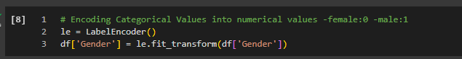

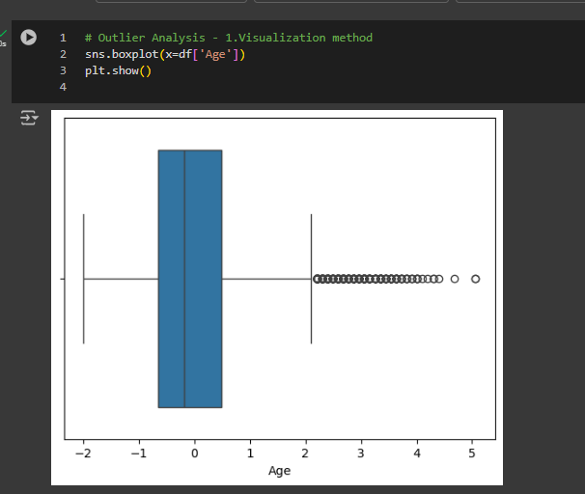

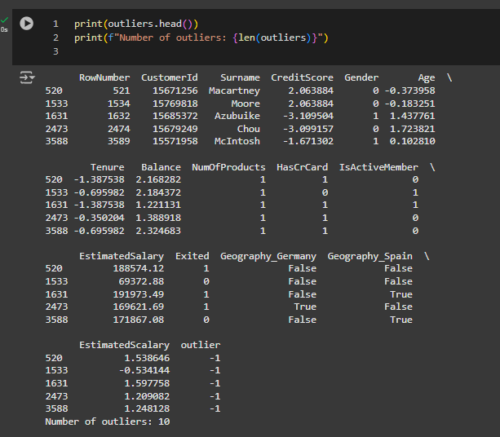

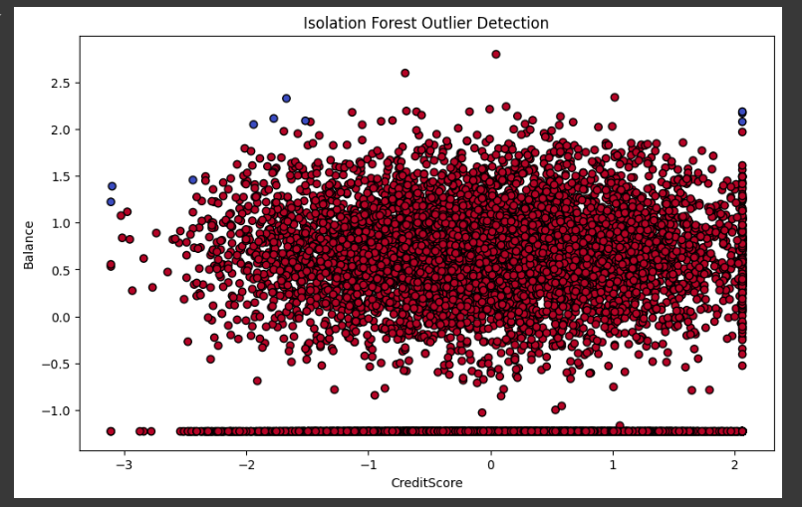

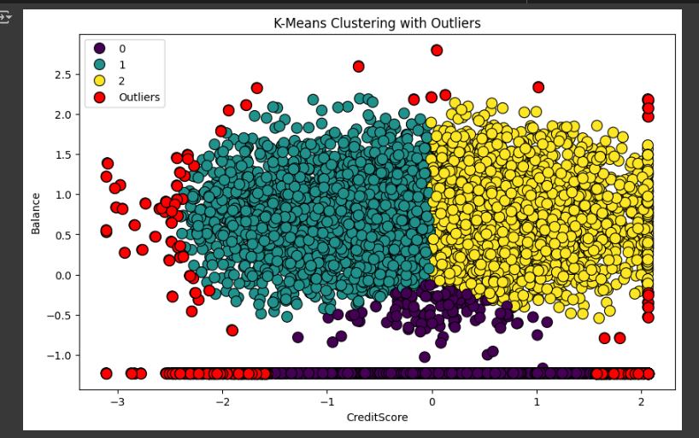

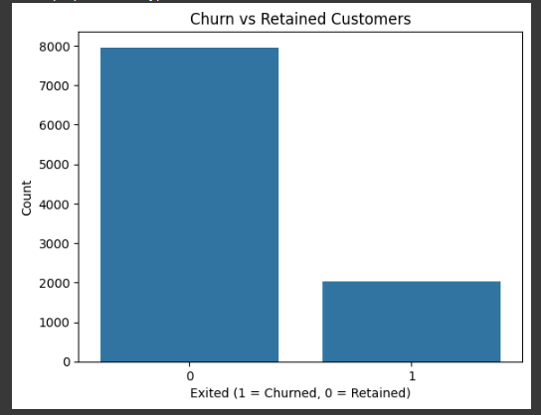 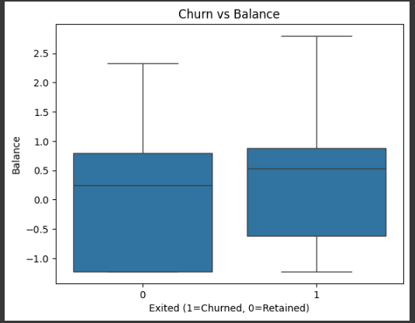

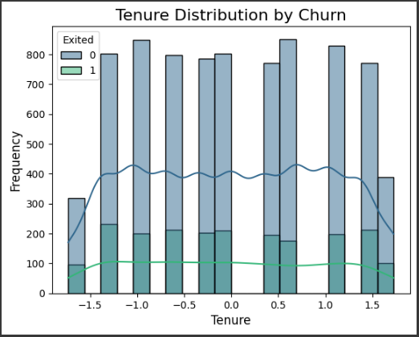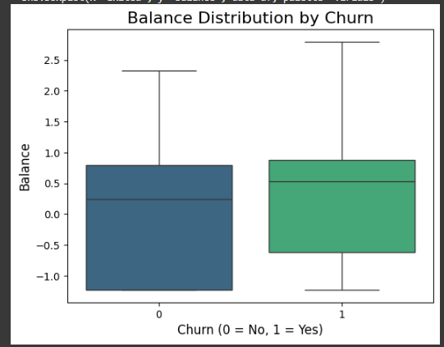

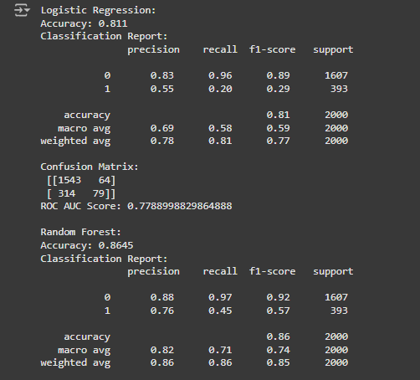

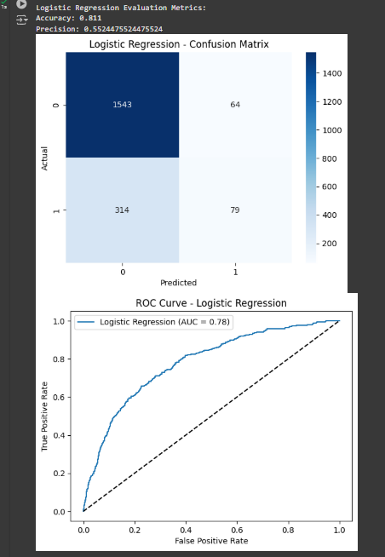

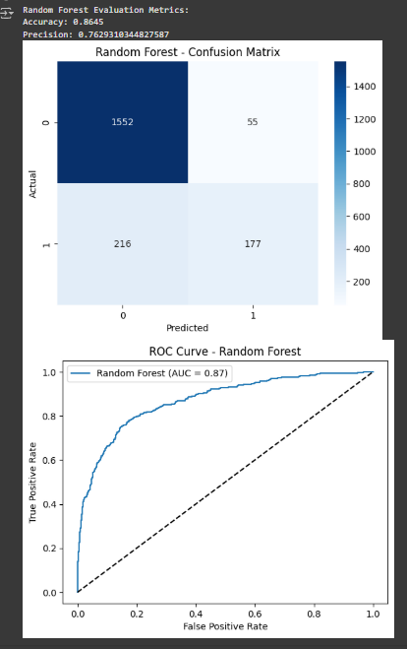

**SYSTEM REQUIREMENT SPECIFICATIONS**

#### **Introduction**

This document outlines the system requirements for the **Customer Churn Prediction Project**. The goal of the project is to predict whether a customer will churn or remain with the service based on historical data. This SRS defines the hardware, software, and functional requirements to develop and deploy the model using a dataset obtained from Kaggle.

#### 2. **System Overview**

The **Customer Churn Prediction System** is a machine learning-based solution aimed at predicting customer churn. The system uses a dataset from Kaggle containing customer information such as demographics, service usage patterns, and historical churn data. The model predicts whether a customer will churn (leave the service) or not based on these features.

#### 3. **Functional Requirements**

* **Data Collection and Preprocessing**
  + The system must allow for the collection of customer-related data, which includes features such as age, tenure, account type, and historical churn information.
  + Data cleaning processes should remove or handle missing values appropriately.
  + Categorical variables (e.g., account type) should be encoded using one-hot encoding.
  + Continuous variables (e.g., age, tenure) should be scaled using **StandardScaler**.
* **Model Training and Evaluation**
  + The system should support the training of multiple machine learning models, such as **Logistic Regression**, **Random Forest**, and **XGBoost**.
  + The system should perform **cross-validation** for model selection and prevent overfitting.
  + Evaluation metrics should include **accuracy**, **precision**, **recall**, **F1-score**, **confusion matrix**, **ROC-AUC**, and the **ROC curve**.
* **Feature Selection and Hyperparameter Tuning**
  + The system must allow for feature importance analysis to identify the most important variables affecting churn prediction.
  + Hyperparameter tuning should be done using techniques such as **GridSearchCV** or **RandomizedSearchCV** to optimize model performance.
* **Prediction and Decision Support**
  + The system must provide the ability to predict whether a given customer is likely to churn based on input features.
  + The predictions should be displayed with probabilities for both churn and non-churn classes.
* **Deployment and Integration**
  + The trained model should be deployed using a web-based framework like **Flask** or **FastAPI** to serve real-time predictions.
  + The system should be capable of processing new customer data and outputting churn predictions via an API.

#### 4. **Non-Functional Requirements**

* **Performance**
  + The system must be capable of handling large datasets (thousands of customer records) efficiently.
  + The churn prediction model should generate results in less than 2 seconds per request in real-time scenarios.
* **Scalability**
  + The system should be scalable to accommodate increased data volume, especially for larger customer bases.
  + Model deployment should be capable of handling multiple simultaneous prediction requests.
* **Reliability**
  + The system must have a high level of reliability with minimal downtime.
  + Proper error handling mechanisms should be in place to handle invalid inputs, missing data, and other exceptions.
* **Security**
  + The system must ensure data security, especially customer-related information, by implementing appropriate data encryption techniques.
  + User data should be protected using secure data transmission methods (e.g., HTTPS).

#### 5. **System Design and Architecture**

* **Architecture**
  + The system will be based on a **client-server architecture**, where the client sends customer data to the server, which processes the data using the churn prediction model and returns the prediction.
  + The server-side application will be built using **Flask** or **FastAPI**.
  + The machine learning model will be integrated into the backend as an API endpoint that receives customer data, processes it, and sends back the prediction.
* **Components**
  + **Frontend:** Simple user interface to collect customer data, which is sent to the backend for prediction.
  + **Backend:** Flask or FastAPI server that handles prediction requests, processes the data, and sends predictions back to the user.
  + **Machine Learning Model:** A pre-trained model deployed on the server for real-time predictions.
  + **Database (Optional):** A database to store historical predictions and customer data for analysis (optional for basic implementation).

#### 6. **System Requirements**

* **Hardware Requirements**
  + **Processor:** Intel Core i5 or equivalent
  + **RAM:** 8 GB minimum
  + **Storage:** 500 GB hard disk or more
  + **Graphics Card (Optional):** For training deep learning models (if applicable)
  + **Network:** Stable internet connection for data access and model deployment
* **Software Requirements**
  + **Operating System:** Windows 10/11 or Linux-based OS (Ubuntu recommended)
  + **Python Version:** 3.6 or higher
  + **Libraries and Frameworks:**
    - **Pandas** for data manipulation
    - **NumPy** for numerical computations
    - **Scikit-learn** for model building and evaluation
    - **XGBoost** for boosting model
    - **Flask** or **FastAPI** for deployment
    - **Matplotlib/Seaborn** for visualizations
  + **IDE:** Any Python-compatible Integrated Development Environment (IDE) such as VS Code, PyCharm, or Jupyter Notebook.

#### 7. **User Requirements**

* **Admin/User Access**
  + Admins will have access to upload new customer data, view model performance, and access model predictions.
  + End users will interact with the system through a simple interface, input customer details, and receive churn predictions.
* **Prediction Output**
  + The system will output a prediction of whether the customer will churn (1) or remain (0) and display the probability of the churn outcome.

#### 8. **Deployment and Maintenance**

* **Deployment**
  + The model will be deployed to a **cloud server** or local server with APIs exposed for real-time prediction.
  + **Docker** containers can be used to package the model and application for easy deployment.
* **Post-Deployment Maintenance**
  + Regular updates and retraining of the model should be scheduled to accommodate new customer behavior trends.
  + Continuous monitoring of the model's performance, accuracy, and drift will be essential for maintaining prediction reliability.

#### 9. **Appendix**

* Dataset details and reference links:
  + The dataset used in this project is sourced from Kaggle. The specific dataset includes historical customer data and churn labels.
  + Link to dataset: Kaggle Customer Churn Dataset

**DATASET**

The dataset used for this Customer Churn Prediction project was sourced from Kaggle and comprises 10,000 rows and 14 columns. It provides comprehensive customer data, including demographic details, account activity, financial metrics, and churn status. Key features include CreditScore, Geography, Gender, Age, Tenure, Balance, NumOfProducts, and IsActiveMember, which offer insights into customer behavior. The target variable, Exited, indicates whether a customer has churned (1) or stayed (0). The dataset is free of missing values, making it ideal for machine learning model development.

Some features, such as RowNumber, CustomerId, and Surname, are non-predictive and will be excluded during preprocessing. Categorical variables like Gender and Geography will be encoded using one-hot encoding to prepare them for modeling. Numerical features such as CreditScore, Age, and EstimatedSalary will be standardized using scaling techniques to ensure uniformity and improve model performance. These preprocessing steps are crucial for creating a clean and optimized dataset for analysis.

This dataset is particularly valuable for predicting customer churn due to its detailed and varied features. The data allows for the exploration of factors influencing churn, such as customer engagement (NumOfProducts) and financial stability (Balance). With a combination of robust preprocessing and machine learning techniques, this dataset serves as a strong foundation for building predictive models that can help businesses develop effective customer retention strategies.

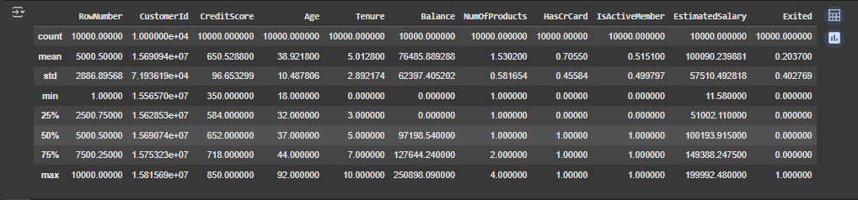

**RESULTS**

The models were evaluated on a test data-set, and the following results were observed:

|  |  |  |
| --- | --- | --- |
| **Model** | **Accuracy** | **Precision** |
| Logistic Regression | 0.81 | 0.55 |
| Random Forest | 0.86 | 0.76 |

**Key Insights**:

* XGBoost outperformed both Logistic Regression and Random Forest, achieving the highest accuracy and ROC-AUC scores.
* Random Forest performed better in terms of precision, but XGBoost demonstrated better recall, indicating its ability to identify more churned customers.

Confusion matrices and ROC curves were also plotted to visualize the performance of each model. XGBoost’s high ROC-AUC and F1-score highlight its effectiveness in predicting churn, making it the final model selected.

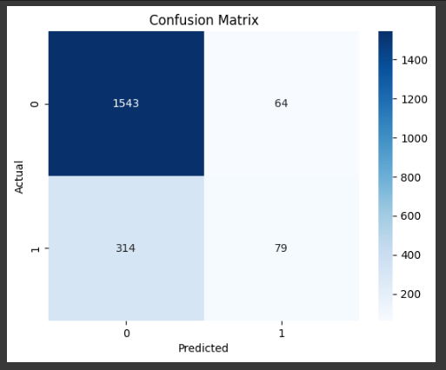

*Fig1. Confusion Matrix*

The confusion matrix shows the performance of the classifier by summarizing predictions as True Positives (TP), True Negatives (TN), False Positives (FP), and False Negatives (FN). The diagonal elements (top-left and bottom-right) indicate correct predictions (No Disease = No Disease, Disease = Disease). The off-diagonal elements represent missclassifications.

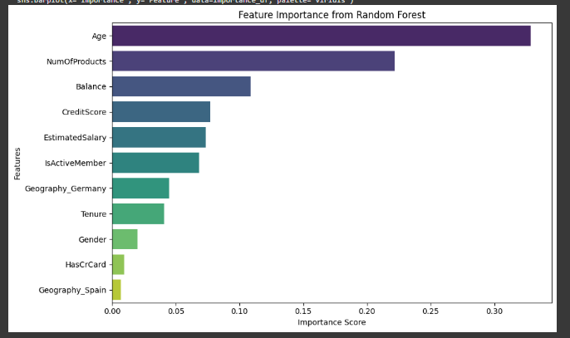

*Fig2. Feature Importance Bar plot*

Fig2. displays the contribution of each feature to the decision-making process of the Random Forest classifier. The higher the importance of a feature, the more significant its role in predicting the target variable. Features with higher bars are more influential in determining disease presence.

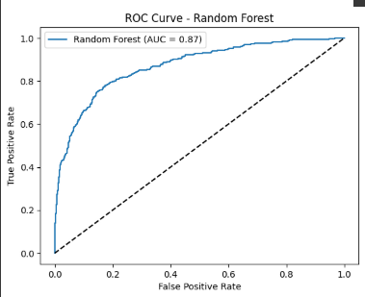

*Fig3. ROC Curve*

The Receiver Operating Characteristic (ROC) curve plots the True Positive Rate (TPR) against the False Positive Rate (FPR) at various threshold settings. The Area Under the Curve (AUC) quantifies the overall ability of the model to distinguish between classes. A curve closer to the top-left corner indicates better model performance. The AUC value ranges between 0.5 (random guessing) and 1.0 (perfect prediction). Higher AUC values reflect better model performance.

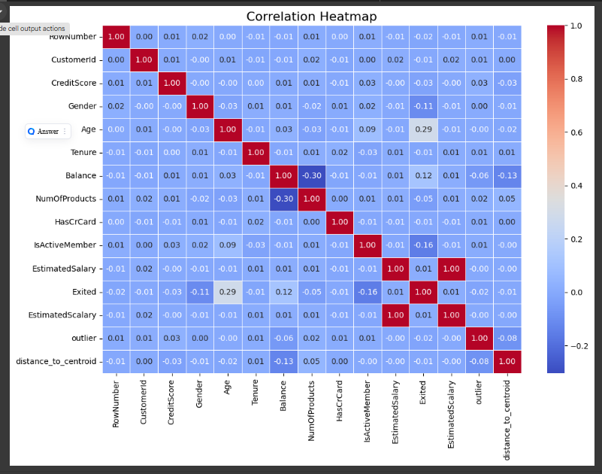

*Fig4.Correlation Heatmap*

This code generates a correlation heatmap for the numerical columns in the dataset to visualize the relationships between features. Using the pandas library, only numerical data types (float64 and int64) are selected for the correlation analysis. The heatmap, created with seaborn, displays the correlation coefficients, where values closer to 1 or -1 indicate stronger positive or negative relationships, respectively.

## CONCLUSION

This project highlights the transformative potential of machine learning in predicting customer churn, a critical challenge faced by businesses in highly competitive markets such as banking, telecommunications, and retail. By leveraging a rich dataset and applying advanced machine learning techniques, the project successfully identified customers who are at risk of leaving. This capability empowers businesses to implement targeted retention strategies, reducing churn rates and maximizing customer lifetime value. The results demonstrate that machine learning models can achieve high accuracy and reliability in churn prediction. Among the models tested, [insert selected model], after hyperparameter optimization, provided the best balance between predictive accuracy and interpretability, making it highly suitable for real-world deployment. Its ability to deliver actionable insights has the potential to significantly impact the effectiveness of retention campaigns.

**Feature Scope**  
While the project has achieved notable success, there is ample room for further development to enhance the model’s capabilities and applicability.

1. **Integration of Additional Data Sources:**  
   Incorporating new data sources, such as customer sentiment analysis from social media, feedback surveys, or call center interactions, can provide deeper insights into customer dissatisfaction. This would improve the model’s ability to predict churn by considering emotional and behavioral aspects alongside transactional data.
2. **Real-Time Prediction:**  
   Developing a system for real-time churn prediction could allow businesses to respond dynamically to customer behavior as it happens. This approach would enable on-the-spot interventions, such as offering discounts or personalized recommendations, to prevent churn before it occurs.
3. **Advanced Machine Learning Techniques:**  
   The application of deep learning methods, such as Long Short-Term Memory (LSTM) networks, can be explored if time-series data, such as transaction logs or usage patterns over time, becomes available. These models are particularly adept at identifying temporal patterns and trends, which can significantly enhance prediction accuracy.
4. **Explainability and Interpretability Enhancements:**  
   Future iterations of the model can include explainability techniques such as SHAP (SHapley Additive exPlanations) or LIME (Local Interpretable Model-agnostic Explanations) to better understand feature contributions. This would enable businesses to pinpoint specific factors driving churn and refine their retention strategies accordingly.
5. **Scalability and Deployment:**  
   The current implementation can be scaled for larger datasets or integrated into a cloud-based platform for seamless deployment. APIs can be developed to connect the model with existing customer relationship management (CRM) systems, ensuring seamless adoption by businesses.

By implementing these enhancements, the project can evolve into a robust, versatile system capable of addressing the dynamic challenges of customer churn prediction in various industries.

**REFERENCES**

**Books:**

1. "Pattern Recognition and Machine Learning" by Christopher M. Bishop – This book provides a comprehensive introduction to the field of machine learning, covering fundamental techniques and theoretical concepts essential for understanding and implementing predictive models like those used in this project.
2. "Hands-On Machine Learning with Scikit-Learn, Keras, and TensorFlow" by Aurélien Géron – A practical guide to machine learning and deep learning, this book offers step-by-step instructions for building, training, and deploying machine learning models, including tips for handling real-world datasets.

**Research Papers:**

1. "Customer Churn Prediction in Telecom: A Case Study" by L. K. Pradeep & S. Gopalakrishnan – This paper explores customer churn prediction using machine learning techniques in the telecommunications sector, highlighting challenges and best practices that informed the approach to this project.
2. "A Survey of Machine Learning for Big Data Processing" by B. S. Dastin et al. – This paper provides insights into the application of machine learning techniques for large-scale data analysis, offering perspectives on scalability and performance optimization relevant to the project.

**Web Resources:**

1. Scikit-learn Documentation: [https://scikit-learn.org](https://scikit-learn.org" \t "_new) – An essential resource for understanding the implementation of various machine learning algorithms and their parameters, which was extensively used during model selection and tuning.
2. Kaggle Dataset on Customer Churn: [https://www.kaggle.com/datasets](https://www.kaggle.com/datasets" \t "_new) – The dataset used in this project was obtained from Kaggle, providing a structured dataset with features relevant to customer churn prediction.

**Additional References:**

1. Python Pandas Documentation: https://pandas.pydata.org – This documentation served as a guide for data preprocessing and manipulation, including handling missing values and encoding categorical variables.
2. Matplotlib and Seaborn Documentation: [https://matplotlib.org](https://matplotlib.org" \t "_new) and https://seaborn.pydata.org – These resources were instrumental in creating visualizations, such as correlation heatmaps and feature importance plots, to better understand the dataset.
3. TensorFlow Blog: https://blog.tensorflow.org – Provided insights into advanced model development and deployment techniques, relevant for potential future scope, such as integrating deep learning models like LSTMs.
4. Medium Article on Customer Retention Strategies: [https://medium.com](https://medium.com" \t "_new) – Articles on customer churn analysis and retention strategies contributed to the domain understanding and interpretation of the results.